Web Server and Application Server

Web Server:

* A Computer System that hosts Websites.
* Runs Web Server software.

How Web Server works:

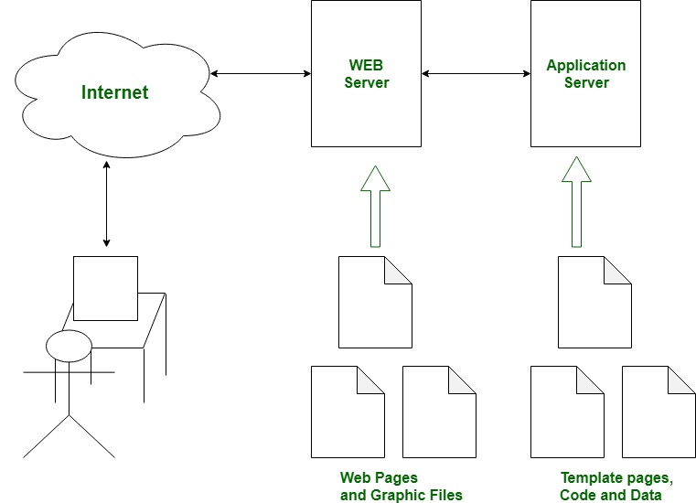

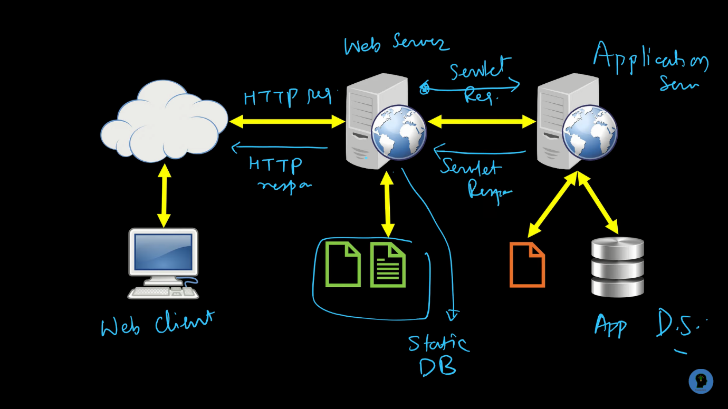

Examples – Web Server

* Apache HTTP Server – Apache Software Foundation
* Internet Information Services (IIS) – Microsoft
* Lightpd
* Sun Java System Web Server
* Jigsaw Server

Application Server

* A Server specially designed to run applications.
* Includes both hardware & software that provide an environment for programs to run.
* Used for –
* Running web applications
* Distributing and monitoring software updates
* Processing data sent from another server

Protocol:

A Protocol is a standardized set of rules for formatting and processing data.

Types of Protocols:

1. Transmission Control Protocol (TCP)
2. Internet Protocol (IP)
3. User Datagram Protocol (UDP)
4. Post office Protocol (POP)
5. Simple mail transport Protocol (SMTP)
6. File Transfer Protocol (FTP)
7. Hyper Text Transfer Protocol (HTTP)
8. Hyper Text Transfer Protocol Secure (HTTPS)
9. Telnet
10. Gopher

Transmission Control Protocol (TCP):

* TCP is one of the main protocols in TCP/IP networks. Whereas the IP protocol deals only with packets, TCP enables two hosts to establish a connection and exchange streams of data.
* TCP guarantees delivery of data and also guarantees that packets will be delivered in the same order in which they were sent.

Internet Protocol (IP):

* IP stands for "Internet Protocol," which is the set of rules governing the format of data sent via the internet or local network.
* In essence, IP addresses are the identifier that allows information to be sent between devices on a network: they contain location information and make devices accessible for communication.

User Datagram Protocol (UDP):

* **User Datagram Protocol** (UDP) is a communications protocol that is primarily used to establish low-latency and loss-tolerating connections between applications on the internet.

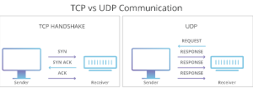

Simple Mail Transfer Protocol (SMTP):

* The main purpose of SMTP is used to set up communication rules between servers.
* The servers have a way of identifying themselves and announcing what kind of communication they are trying to perform.
* They also have a way of handling the errors such as incorrect email address.
* For example, if the recipient address is wrong, then receiving server reply with an error message of some kind.

File Transfer Protocol (FTP):

* FTP is a standard internet protocol provided by TCP/IP used for transmitting the files from one host to another.
* It is mainly used for transferring the web page files from their creator to the computer that acts as a server for other computers on the network.
* It is also used for downloading the files to computer from other services.

Why FTP:

* Although transferring files from one system to another is very simple and straightforward, but sometimes it can cause problems.
* For example, two systems may have different file conventions.
* Two systems may have different ways to represent text and data. Two systems may have different directory structures.
* FTP protocol overcomes these problems by establishing two connections between hosts. One connection is used for data transfer, and another connection is used for the control connection.

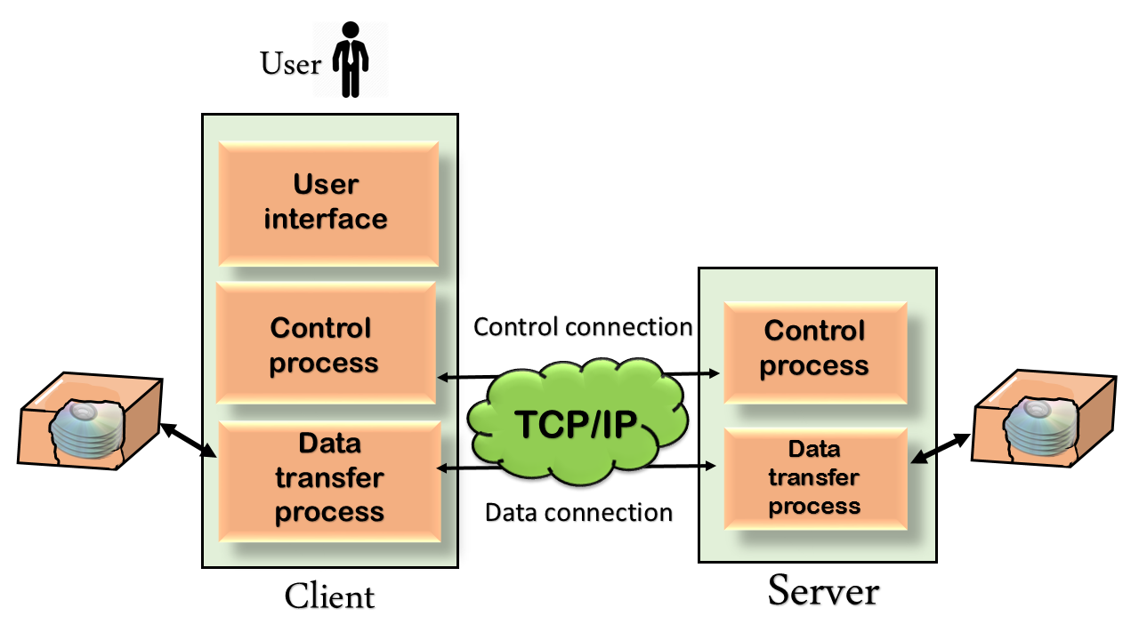

Hyper Text Transfer Protocol (HTTP):

* HTTP is used to access data on the World Wide Web (WWW).
* The HTTP protocol can be used to transfer the data in the form of plain text, hypertext, audio, video and so on.
* HTTP is similar to SMTP as the data is transferred between client and server. The HTTP differs from the SMTP in the way the messages are sent from the client to the server and from server to the client. SMTP messages are stored and forwarded while HTTP messages are delivered immediately.

Features of HTTP:

* Connectionless protocol.
* Media independent.
* Stateless.

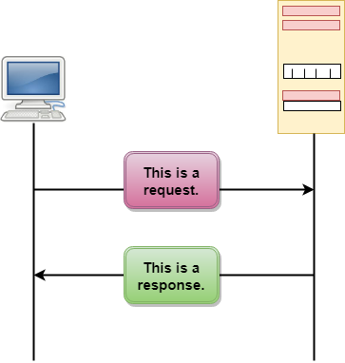

The above figure shows the HTTP transaction between client and the server. The client initiates a transaction by sending a request message to the server. The server replies to the request message by sending a response message.

Hyper Text Transfer Protocol Secure (HTTPS):

* It is a protocol for securing the communication between two systems.

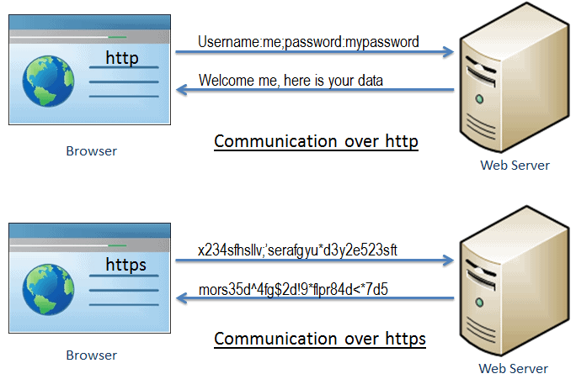

As you can see in the above figure, http transfers data between browser and web server in a hypertext format, whereas https transfers data in the encrypted format.

Because https prevents hackers from reading and modifying the data during the transfer between the browser and the web server.

HTTPS established an encrypted link between the browser and the web server using the Secure Socket Layer (SSL) or Transport Layer Security (TLS) protocols. TLS is the new version of SSL.

Secure Socket Layer (SSL):

SSL is a standard security technology for establishing an encrypted link between the two systems. These can be browser to server, server to server or client to server.

The https is essentially http over SSL. SSL establishes an encrypted link using an SSL certificate which is also known as a digital certificate.

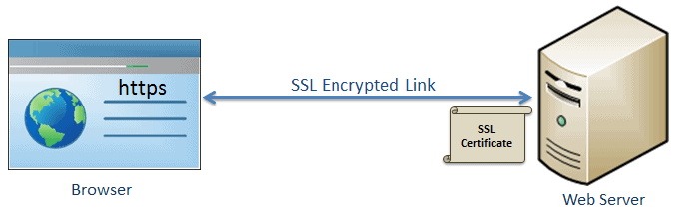

Differences between http and https:

|  |  |
| --- | --- |
| HTTP | HTTPS |
| Transfers data in hypertext format | Transfers data in encrypted format |
| Uses port 80 by default | Uses port 443 by default |
| Not secure | Secured using SSL technology |
| Starts with http:// | Starts with htpps:// |

Advantage of HTTPS:  
1. Secure Communication.  
2. Data Integrity.  
3. Privacy and Security.  
4. Faster Performance.  
5. SEO  
6. Future.

Telnet Protocol:

* The Telnet Protocol (TELNET) provides a standard method for terminal devices and terminal-oriented processes to interface.
* Telnet is a protocol to provide communication over the Internet or a LAN a using a virtual terminal connection. It is installed by default on Linux and older Mac operating systems, but must be installed on Windows and macOS High Sierra 10.13 and later.

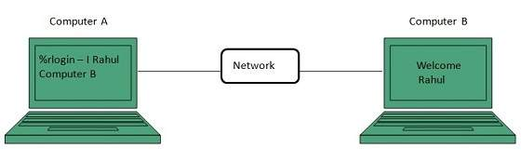

Gopher:

* The Gopher protocol is a communication protocol designed for distributing, searching, and retrieving documents in Internet Protocol networks.
* The gopher protocol is turned off by default in Microsoft Internet Explorer 6 for Windows XP Service Pack 2 (SP2). The protocol has been removed from Microsoft Win32 Internet in Windows Internet Explorer 7 and later versions.

Post Office Protocol (POP)

* POP is an application layer protocol.
* Used by clients for retrieving emails and it always support a single client.
* POP allows downloading messages from your inbox to your local computer.
* Latest version is POP3.
* IMAP and SMTP is used for accessing emails but main advantage if POP is it supports offline to messages.

POP Commands

* LOGIN – Opens the connection
* STAT – Shows the list of messages in your mail box.
* LIST – Summary of the messages
* RETR – Retrieve the messages
* DELE – Deleting the messages
* RSET – Resetting the session
* QUIT – Log off



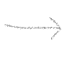

From the above figure, if client A sends the response when the client B is in offline, then that message is stored in the POP server and he receives those messages when he is in online.

